
Digital Job Matching System (DJMS)
Software Requirement Specification
– Da Nang, May 2025 –
1
Table of Contents
1. Product Overview ..................................................................................................................5
1.1 Context Diagram..............................................................................................................5 1.2 Main Workflows...............................................................................................................7 1.2.1 Register to become company ....................................................................................7 1.2.2 Find A Job .................................................................................................................8 2. User Requirements.................................................................................................................9
2.2 Use Cases.......................................................................................................................10 2.2.1 Diagram(s) ..............................................................................................................10 2.2.2 Descriptions ............................................................................................................16 3. Functional Requirements .....................................................................................................20
3.1 System Functional Overview.........................................................................................20 3.1.1 Screens Flow...........................................................................................................20 3.1.2 Screen Descriptions.................................................................................................23 3.1.3 Screen Authorization...............................................................................................24 3.1.4 Non-Screen Functions.............................................................................................26 3.1.5 Entity Relationship Diagram...................................................................................26
3.2 Register ..........................................................................................................................28 3.3 Login ..............................................................................................................................31 3.4 Forgot Password Function Description..........................................................................33 3.5 Job Posting Management ...............................................................................................36
3.5.1 Create Job Posting...................................................................................................36 3.5.2 Edit Job Posting ......................................................................................................38 3.5.3 Delete Job Posting...................................................................................................39
3.6 Candidate Search............................................................................................................41 3.7 Company Profile Management ......................................................................................43 3.8 Mark Potential Candidates.............................................................................................45 3.9 Job Search & Apply Job.................................................................................................47 3.10 CV & Profile Management ..........................................................................................49 3.11 Personal Workspace .....................................................................................................51 3.12 Purchase VIP Packages for Users ................................................................................52 3.13 AI-Based Skill Analysis...............................................................................................54
2
3.14 Application History & Feedback Management............................................................55 3.15 User Management ........................................................................................................57 3.16 Send System Notifications...........................................................................................58 3.17 Content Moderation .....................................................................................................59 3.18 Fraud Handling & Reporting .......................................................................................61 3.19 System Activity Monitoring.........................................................................................62 3.20 Video Call.....................................................................................................................63 3.21 AI-Generated Career Roadmap....................................................................................64 3.32 Candidate Interaction ...................................................................................................66 4. Non-Functional Requirements.............................................................................................68
4.1 External Interfaces .........................................................................................................68 4.1.1 User Interfaces ........................................................................................................68 4.1.2 Software Interfaces .................................................................................................68 4.2 Quality Attributes.......................................................................................................68 5. Requirement Appendix ........................................................................................................70
5.1 Business Rules ...............................................................................................................70 5.2 Application Messages List .............................................................................................71
3
I. Record of Changes
Date | A*  M,  D | In charge | Change Description
19/05/2025 | A | FCC Team | Add initial version
20/5/2025 | M | FCC Team | Create base document
1/6/2025 | M | FCC Team | Update mentor’s comment
10/6/205 | M | FCC Team | Update mentor’s comment
15/8/2025 | M | FCC Team | Final report

*A - Added M - Modified D – Deleted
4
II. Software Requirement Specification
1. Product Overview
1.1 Context Diagram
FCC (FCareerConnect) is a modern job platform designed to improve how employers and Users connect and work together. While traditional job sites are often basic and limited, FCC uses smart features and AI to create a better and more personalized experience for everyone.
Our platform helps companies post jobs, find the right candidates, and manage the hiring process more easily. At the same time, Users can search for jobs, apply directly, and grow their careers using helpful tools and suggestions.
FCC supports secure logins using email, Google, or Facebook. Users are verified through email or OTP to ensure account safety. The platform offers an easy-to-use interface, helping Users search by keywords, skills, location, and salary. They can apply with their CVs, take tests if needed, and track all applications in one place.
Users can also build smart CVs with AI help, check their skills, and get suggestions for improvement. They receive job alerts and career advice based on their goals and activities. Companies can upgrade job posts to VIP, highlight them to get more views, and manage candidates using tags and roles. They can schedule online interviews using built-in video calls, send messages, and track hiring results with downloadable reports.
Admins have full access to manage the system. They can approve or remove content, handle user reports, send notifications, and view platform statistics. With these tools, they keep FCC safe and reliable for everyone.
FCC is designed to make hiring and job searching easier and smarter. Whether you are a Company Looking for talent or a User planning your future, FCC gives you the tools to succeed in your career journey.
5
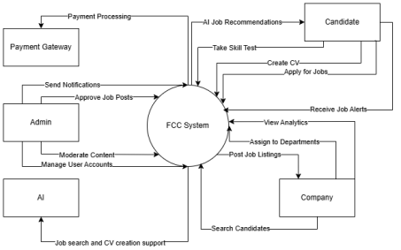Figure 1: Context Diagram for the system
6
1.2 Main Workflows
1.2.1 Register to become company
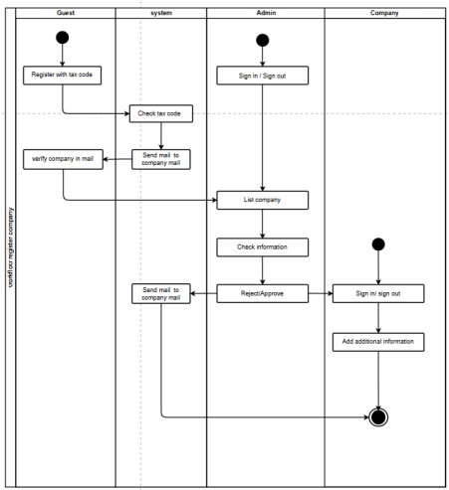Figure 2: Work Flow of Register To Become Company
7
1.2.2 Find A Job
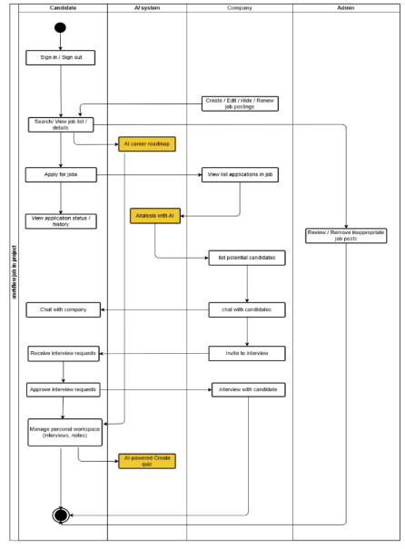Figure 3: Work Flow Of Find A Job
Link of work flow: Find a Job
8
2. User Requirements
2.1 Actors
# | Actor | Description
1 | Guest | A guest is someone who has not created an account on the system. Guests can view job postings, job details, search for jobs, and browse public company profiles and CV templates. They cannot interact with companies or apply for jobs.
2 | User | A user is a registered individual who can apply for jobs, create and manage CVs (with AI suggestions), receive job alerts, manage personal profiles, and track application status. Users can also chat with companies, receive interview invitations, manage their workspace, and purchase VIP packages.
3 | Company | A company is a verified organization that can post and manage job listings, search and bookmark potential candidates, invite candidates to interviews, and rate applicants. Companies can edit their profiles, interact with users, and purchase VIP packages.
4 | Admin | An admin is responsible for platform governance. They can monitor and manage all accounts, approve or remove job postings, handle scam reports, oversee system notifications, review reports, manage payment records, and track overall platform usage and AI performance. Admins also handle company verifications and policy violations (ban, unban, or delete accounts).

Table 1: Actor description
9
2.2 Use Cases
2.2.1 Diagram(s)
2.2.1.1. Use Case Use Case for Authentication
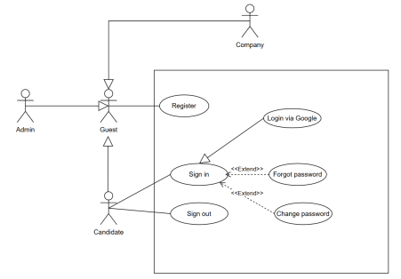Figure 4: Use Case Authentication
10
2.2.1.2. Use Case for Overview
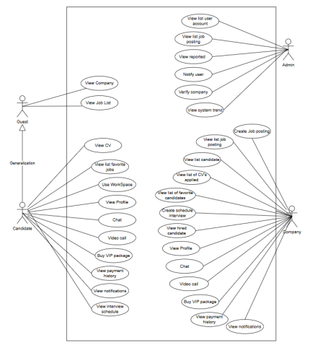Figure 5: Use case overview
11
2.2.1.3. Use Case for Guest
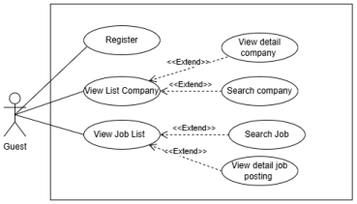Figure 6: Use case diagram for Guest
12
2.2.1.4. Use Case for Candidate
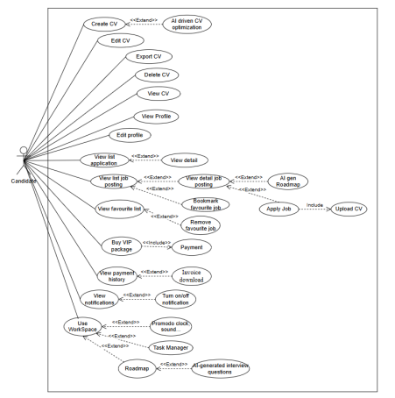Figure 7: Use case diagram for Candidate
13
2.2.1.5. Use Case for Company
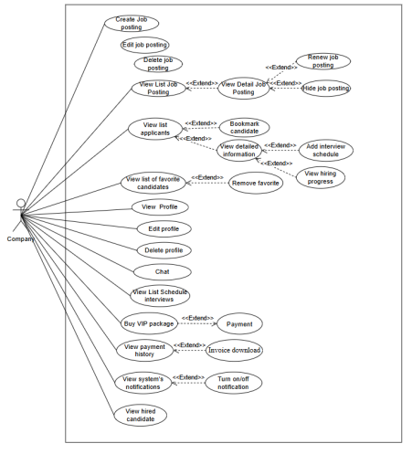Figure 8: Use case diagram for Company
14
2.2.1.6. Use Case for Admin
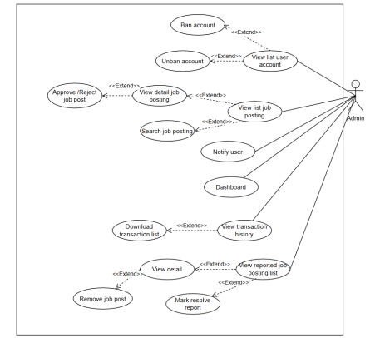Figure 9: Use case diagram for Admin
15
2.2.2 Descriptions
ID | Use Case | Actors | Use Case Description
UC-01 | Sign-Up | Guest | Guest registers using email/password or social accounts. Verification via email is required.
UC-02 | Sign-In | Guest | Guest logs into the system using registered credentials.
UC-03 | Forgot Password | Guest | Guest requests password reset via email with a system-generated link.
UC-04 | Change Password Candidate |  | Candidate changes password after logging in.
UC-05 | View Job  Listings | Guest, Candidate | View and search job listings with filters.
UC-06 | View Job Detail | Guest, Candidate | View full details of a selected job posting.
UC-07 | Search Job  Postings | Guest, Candidate | Search job postings by keywords, filters, or categories.
UC-08 | Add Job to  favorite | Candidate | Candidates add a job to their favorite list.
UC-09 | Remove Job  from favorite | Candidate | Candidates remove a job from their favorite list.
UC-10 | View favorite  Jobs | Candidate | Candidates view the list of their favorite jobs.
UC-11 | Search Company | Guest, Candidate | Candidates search companies by name or industry.
UC-12 | View All  Companies | Guest, Candidate | Candidate views a list of all registered companies on the platform.
UC-13 | Apply for Job | Candidate | Candidate applies for a job using a selected CV.

16
UC-14 | Track  Application  Status | Candidate | Candidate views status and history of job applications.
UC-15 | Create Job  Posting | Company | Company creates a new job posting.
UC-16 | Edit Job Posting | Company | Company edits an existing job posting.
UC-17 | Renew Job  Posting | Company | Company renews an expired job posting.
UC-18 | Update Job  Status | Company | Company updates the status of a job posting.
UC-19 | Hide Job Posting | Company | Company hides job postings from public view.
UC-20 | Approve Job  Posting | Admin | Admin approves a submitted job posting.
UC-21 | Delete Job  Posting | Company | Company deletes a job posting.
UC-22 | Search  Candidates | Company | Company searches for candidates using filters.
UC-23 | View User’s  Profile | Company, Candidate | User view their personal profile
UC-24 | Edit Profile | Candidate,  Candidate | User edit their personal profile.
UC-25 | Bookmark  Candidate | Company | Company bookmarks potential candidates.
UC-26 | Invite to  Interview | Company | Company invites candidates to an interview.
UC-27 | Manage  Interviews | Company | Company manages interview  schedules and internal notes.

17
UC-28 | Rate Candidate | Company | Company rates the performance of a candidate.
UC-29 | Create Company Profile | Company | Company creates its public profile.
UC-30 | Edit Company Profile | Company | Company edits its public profile.
UC-31 | Delete Company Profile | Admin | Admin deletes a company profile.
UC-32 | Verify Company | Admin | Admin verifies authenticity of a company.
UC-33 | Create CV | Candidate | Candidate creates a CV with or without AI assistance.
UC-34 | Edit CV | Candidate | Candidate edits an existing CV.
UC-35 | Delete CV | Candidate | Candidate deletes a CV.
UC-36 | Upload CV | Candidate | Candidate uploads a pre-created CV file.
UC-37 | Export CV to  PDF | Candidate | Candidates export their CV in PDF format.
UC-38 | Direct  Messaging | Candidate, Company | Candidates and companies exchange messages via system.
UC-39 | Video Call | Candidate, Company | Candidates and companies exchange video call via system.
UC-40 | Interview  Requests | Candidate, Company | Candidate receives or approves interview requests.
UC-41 | View  Notifications | Candidate, Company | Candidate views system notifications and alerts.
UC-42 | Toggle  Notifications | Candidate, Company | Candidate turns system notifications on or off.
UC-43 | View Reports | Admin | Admin views platform-generated reports.

18
UC-44 | Review Reports | Admin | Admin reviews details of reported content.
UC-45 | View system  trend | Admin | Admin tracks platform usage metrics.
UC-46 | Handle Scams | Admin | Admin investigates and handles scam job posts.
UC-47 | Manage Users | Admin | Admin bans/unbans accounts.
UC-48 | View all user  account | Admin | Admin view all user account in the system.
UC-49 | Export user data to PDF | Admin | Admin can view and export user data.
UC-50 | Task Manager | Candidate | Candidate create, edit, management task in Workspace.
UC-51 | Pomodoro Timer, sound,  background  support tool | Candidate | Candidate use support tool in  Workspace to manage time/ work effective
UC-52 | AI support test quiz | Candidate | AI generates quiz based on their roadmap
UC-53 | AI Skill Analysis | Company | AI evaluates candidate's CV and gives score
UC-54 | AI Career  Roadmap | Candidate | AI builds personalized career  development roadmap.
UC-55 | AI CV  Optimization | Candidate | AI enhances CV with keyword and formatting improvements.
UC-56 | Payment  Integration | Candidate, Company | Candidate and companies make payments through gateways.
UC-57 | Purchase VIP  Job Package | Company | Company purchases VIP job posting services.

19
UC-58 | Purchase VIP  User Package | Candidate | Candidate purchases profile-boosting and roadmap packages.
UC-59 | View Payment History | Candidate, Company | View list of past transactions made on the platform.
UC-60 | Download  Invoice | Candidate, Company | Download invoice for completed transactions.

Table 2: Usecase description
3. Functional Requirements
3.1 System Functional Overview
3.1.1 Screens Flow
3.1.1.1 Screen Flow Of Candidate
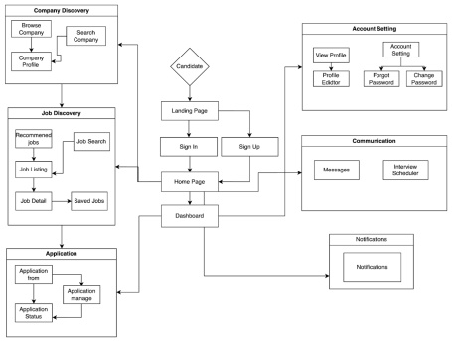Figure 10: Screens Flow of Candidate
20
3.1.1.2 Screen Flow Of Company
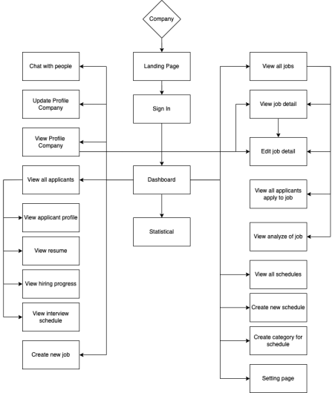Figure 11: Screens Flow of Company
21
3.1.1.3 Screen Flow Of Admin
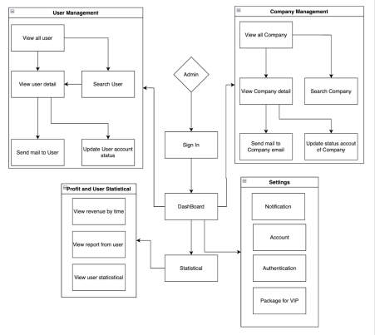Figure 12: Screens Flow of Admin
22
3.1.2 Screen Descriptions
# | Feature | Screen | Description
1 | Landing Page | Landing Page | Initial entry point for candidate users
2 | Sign In | Sign In | Login screen for candidate
3 | Sign Up | Sign Up | Registration screen for candidate
4 | Dashboard | Dashboard | Candidate dashboard after login
5 | Home Page | Home Page | Main workspace of candidate
6 | Browse Company | Browse Company | Browse list of companies
7 | Search Company | Search Company | Search for specific company
8 | Company Profile | Company Profile | View company's public profile
9 | Recommended Jobs | Recommended Jobs | AI recommended jobs for candidate
10 | Job Search | Job Search | Search for jobs by filters
11 | Job Listing | Job Listing | List of available jobs
12 | Job Detail | Job Detail | Detailed view of a specific job
13 | Saved Jobs | Saved Jobs | Jobs saved by the candidate
14 | Application Form | Application Form | Form to apply for a job
15 | Application Manage | Application Manage | Manage submitted applications
16 | Application Status | Application Status | Track status of applications
17 | View Profile | View Profile | View candidate’s own profile
18 | Account Setting | Account Setting | Modify account preferences

23
19 | Profile Editor | Profile Editor | Edit resume/CV and profile info
20 | Forgot Password | Forgot Password | Start password recovery process
21 | Change Password | Change Password | Update password
22 | Messages | Messages | Chat with employers
23 | Interview Scheduler | Interview Scheduler | Schedule upcoming interviews
24 | Workspace | Workspace | Learning career roadmap, task manager, time manager.

Table 3: Screen description
3.1.3 Screen Authorization
Screen | Guest | Candidate | Company | Admin
Authentication (Sign Up / Sign In) | X | X | X | X
Password Recovery | X | X | X | X
Landing Page | X | X | X
Home Page (Dashboard) |  | X | X
Create Job Listing |  |  | X
View Job Listings | X | X | X
Update Job Listing |  |  | X
Delete Job Listing |  |  | X
Search for Candidates |  |  | X
Create Company Profile |  |  | X
View Company Profile | X | X | X

24
Update Company Profile |  |  | X
Delete Company Profile |  |  | X
Manage Recruited Candidates |  |  | X
Bookmark Candidates |  |  | X
Purchase VIP Job Packages |  |  | X
Search & Apply for Jobs | X | X
Create CV |  | X
View CV |  | X | X
Update CV |  | X
Delete CV |  | X
Personal Workspace (Candidate Home) |  | X

Table 4: Screen Authorization
25
3.1.4 Non-Screen Functions
# | Feature | System  Function | Description
1 | Authorization | Function for User | All requests to Candidate, Company and Admin functions are passed through the user authorization middleware.
2 | WebSocket  Connection | Connection | Establishes real-time communication for instant notifications and updates between users and the system.
3 | Push  Notifications | Notify users | Sends real-time notifications about ride status, payment confirmations, promotions, and important updates.

Table 5: Non-screen functions
3.1.5 Entity Relationship Diagram
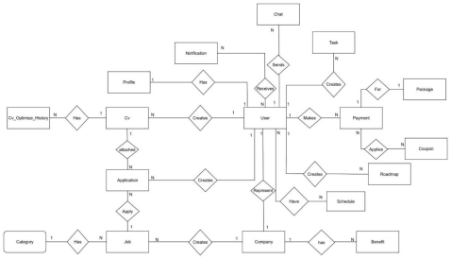Figure 13: Entity Relationship diagram
26
Entities Description
# | Entity | Description
1 | Users | Stores user-related data, including email, password, roles, and verification status.
2 | Candidate Profile | Stores candidate-specific details like education and personal descriptions.
3 | CV | Contains uploaded CVs with content, titles, PDF links, and sharing information.
4 | Company | Company data including name, industry, tax code, and business license info.
5 | Job | Job postings with details such as title, salary, experience, and location.
6 | Job Application | Represents user applications to jobs, including status and attached CVs.
7 | Calendar | Schedules or appointments related to users, such as interviews or meetings.
8 | Payment | Records user payments for packages, coupons used, and transaction status.
9 | Package | Information about service plans users can purchase, like job posting packages.
10 | Coupon | Discount codes applicable to payments, with expiration and activation status.
11 | Notification | System-generated alerts for updates, messages, or actions taken on the platform.
12 | Chat | Stores 1:1 message exchanged between users (e.g., candidate and company).
13 | Candidate Roadmap | Tracks candidate progress in job applications through roadmap steps.

Table 6: Entity Description
27
3.2 Register
Function Description
Allows new individual users or companies to register using email/password or Google/Facebook OAuth. The system verifies identity, creates accounts, and provides authentication tokens.
Actors: Guest
Layout:
Figure 14: Registers
Interface Elements
• Registration Form (Candidate):
o Full Name, Username, Email and password fields.
o “Create Account” button.
• OAuth Buttons:
o Google login options.
• Registration Form (Company):
28
o Fields for HR Full Name, Username, Company email, Tax Code, Company name. o File upload for business license or email verification.
• Verification Interface:
o Email link to verify.
• Success Message:
o Toast notification confirming successful registration.
Data Processing
Input
• Email, password.
• OAuth credentials (if used).
• Company details (for business)
• Verification link or uploaded license.
Processing
• Validate input fields.
• Initiate OAuth flow if chosen.
• Verify email/business license.
• Check for existing email in the database.
• Create a new user or company record.
• Assign default role: candidate or company
• Generate and return JWT tokens.
29
Output
• Confirmation of account creation
• JWT tokens (access, refresh).
• Redirect to the home screen or company dashboard. Validation
• Unique email address.
• Required fields must be completed.
• Passwords must meet policy requirements.
• OAuth token must be valid.
• Email or business license must be verified.
Business Rules
• Registered candidates get role candidate, companies get companies. • OAuth registrations are tied to unique provider IDs. Error Handling
• Duplicate email → error message.
• Verification failed → retry prompt.
• OAuth error → return to registration.
• Missing fields → form validation error.
• System/server error → general error notification
30
3.3 Login
Function Description
Allow existing candidates or companies to log in using email/password or Google OAuth. Upon successful authentication, the system generates session tokens and grants access to the appropriate interface.
Actors: Candidates, company
Layout:
Figure 15: Login
Interface Elements
• Login Form:
o Fields for email and password.
o “Sign-In” button.
• OAuth Buttons:
o Google login options.
• Verification Prompt (if needed):
o For accounts requiring re-verification or 2FA.
31
• Success Notification:
o Toast message or redirection after login.
Data Processing
Input
• Email and password.
• OAuth credentials.
Processing
• Validate credentials or OAuth token.
• Check if the account exists and is verified.
• Authenticate credentials with database or provider.
• Generate JWT tokens.
• Redirect based on role (candidate → home, company → dashboard). Output
• JWT tokens (access, refresh).
• Redirect to the main interface.
• Display login success message.
Validation
• Email must exist and be verified.
• Passwords must match records.
• OAuth tokens must be valid.
• Account must not be blocked or disabled.
32
Business Rules
• Sessions last for 2 days of inactivity.
• Access token valid for 1 hour.
• Refresh token valid for 7 days.
Error Handling
• Invalid credentials → error message.
• Unverified account → prompt for verification.
• OAuth denial → return to login.
• Expired tokens → request new login
• Network/server issues → show connectivity error.
3.4 Forgot Password
Function Description
Allows users who have forgotten their password to securely reset it by verifying their email. The system sends a reset link to the registered email, enabling users to set a new password and regain access.
Layout:
Figure 16: Forgot Password
33
Actors/Roles
• Candidates, Company
Interface Elements
• "Forgot Password" Button:
• Located on the login screen.
• Email Input Field:
• To enter the registered email address.
• Reset Link Email:
• Contains a secure link to the password reset form. • Password Reset Form:
• Fields to input and confirm the new password. • Confirmation Message:
• Toast or dialog confirming password reset success. Data Processing
Input
• Registered email address.
• New password (entered twice for confirmation). • Token from the reset link.
Processing
• Validate the entered email.
• Generate a secure, time-limited token.
• Send password reset link to the email.
34
• When link is accessed:
• Verify token validity and expiration.
• Validate new password.
• Update password in the database.
• Optionally login the user after successful reset.
Output
• Email with reset link.
• Success message after password change.
• Optional automatic login or redirection to login screen.
Validation
• Email must exist in the system.
• Reset token must be valid and not expired.
• New password must meet password policy (e.g., length, complexity). • Password confirmation must match.
Business Rules
• Reset token expires after a short duration (e.g., 15–60 minutes).
• Tokens are one-time use only.
• Password must not be the same as the previous password (optional security rule). Error Handling
• Email not found → show error message.
• Invalid or expired token → show link expiration warning.
• Passwords do not match → show validation error.
35
3.5 Job Posting Management
3.5.1 Create Job Posting
Function Trigger
Company accesses the dashboard and selects “Create Job Posting”.
Function Description
The Company Fills in required information (Job tittle, type of employment, categories, description, skills, location, salary, benefit) and selects a display type (regular or VIP).
Upon submission, the job post is saved to the database and becomes visible on the job listing page.
Layout:
Figure 17: Job posting
36
Actors/Roles: Company
Interface Elements
• “Create Job Posting” button.
• Form fields: Job tittle, type of employment, categories, description, skills, location, salary, benefit
• Toast/notification on success or failure.
Data Processing
Input:
• Job posting data from the form.
Processing:
• Validate required fields.
• Save job posts to the database.
• Set default status to “Active”.
• Calculate expiration date if applicable.
Output:
• New post appears on the job listings page.
• UI updates with success notification.
Business Rules
• All required fields must be filled.
• Only logged-in employers can create posts.
• VIP posts may require verification or fee.
37
3.5.2 Edit Job Posting
Function Trigger
Company selects the “Edit” button on an existing job post.
Function Description
The Company can update job post information (position, description, etc.). Changes are saved and reflected immediately on the job listing page.
Screen Layout:
Figure 18: Edit Job Posting
Actors/Roles: Company
Interface Elements
• “Edit” button.
• Pre-filled form with existing job data.
• “Save Changes” button.
• Notification on success or failure.
38
Data Processing
Input:
• Job post ID and updated data.
Processing:
• Verify post ownership.
• Update job post in the database.
Output:
• Updated post data is reflected in the UI and job listings.
• Success/failure notification.
Business Rules
• Only the post owner can edit.
• Required fields must remain valid.
• Changes are applied immediately.
3.5.3 Delete Job Posting
Function Trigger
Company Selects the “Delete Job” button on a job post.
Function Description
The Company Can permanently delete a job post from the system. Confirmation is required.
39
Layout:
Figure 19: View applicant status
Actors/Roles: Company
Interface Elements
• “Delete” button.
• Confirmation dialog.
• Notification after action is completed.
Data Processing
Input:
• ID of the job post to be deleted.
Processing:
• Verify ownership.
• Show confirmation prompt.
• Delete post from the database upon confirmation.
40
Output:
• Job posts are removed from listings.
• UI reflects deletion and shows a confirmation message.
Business Rules
• Only the owner can delete the post.
• Action requires confirmation.
• Deletion is irreversible.
3.6 Candidate Search
Function Trigger
Company Navigates to the "Search Applicant" section from the Job detail section. Function Description
The Company Can search for potential candidates by applying filters such as skills, experience, job position, and geographic location.
Results are displayed in a list format, and the Company Can view detailed candidate profiles and mark promising candidates for further consideration.
41
Layout
Figure 20: Search applicant
Actors/Roles: Company
Interface Elements
• Filters: skills, experience level, job position, location.
• Candidate cards/list with summary info.
• “View Profile” button to open a detailed view.
• “Mark as Potential” (bookmark/favorite) button.
• Notification/toast for successful marking or errors.
Data Processing
Input:
• Selected filter criteria (skills, experience, position, location), candidate selection actions • .
42
Processing:
• Fetch candidate data from the database based on filter criteria.
• Display matching candidates.
• Load candidate profile when selected.
• Save bookmarking status to the employer’s account.
Output:
• Filtered list of candidates.
• Detailed view of selected profiles.
• UI updates with bookmarked candidates.
• Confirmation messages after actions.
Business Rules
• Only employers with active accounts can access candidate data.
• Filters should support multi-select where applicable.
• Employers can bookmark/unbookmarked candidates.
• Search results should update in real time or on filter submission.
• Privacy rules must be enforced based on candidate visibility settings.
3.7 Company Profile Management
Function Trigger
Company accesses the “Profile” section from the dashboard.
Function Description
Employers can view their company’s public profile, including logo, description, address, and industry. They can update any of these fields to keep their profile accurate and appealing to Users.
43
Screen Layout
Figure 21: Company Profile
Actors/Roles: Company
Interface Elements
• Display fields: Company name, logo, company profile, address, industry, contact information.
• Edit mode with input fields and file upload for logo.
• “Save Changes” button.
• Toast/message notifications for success or error.
Data Processing
Input:
• Updated company profile fields: logo, description, address, contact information, industry.
Processing:
• Validate updated information.
• Save changes to the company profile in the database.
44
Output:
• Updated information displayed in the company profile.
• UI reflects changes.
• Success/failure notification shown.
Business Rules
• Only employers with verified accounts can edit their company profile. • Required fields (e.g. name, industry) must not be left empty.
• Logo must be a valid image file.
• Changes take effect immediately on the public profile.
3.8 Mark Potential Candidates
Function Trigger
Company Click the “Save Profile” button while browsing search results. Function Description
The Company Can bookmark a candidate's profile from the search result list. The saved candidate is added to a dedicated “Bookmark” list for future reference.
45
Layout:
Figure 22: Mark potential candidate
Actors/Roles: Company
Interface Elements
• Save/Bookmark button on candidate cards.
• Potential Candidates list with filtering/sorting.
Data Processing
Input:
• Candidate ID, Company action.
Processing:
• Store candidate as bookmarked under the employer’s account.
• Prevent duplicate entries.
Output:
• Candidates appear in the “Potential Candidates” list.
• Confirmation message displayed.
46
Business Rules
• Only logged-in employers can save candidates.
• Each candidate can only be saved once per employer.
• Saved profiles should be retrievable across sessions.
3.9 Job Search & Apply Job
Function Trigger:
User accesses find job search page and initiates a job search.
Function Description:
The user searches for jobs by entering keywords and applying filters such as salary, location, skills, and job type. The user selects a job from the search results, reads the job description, and clicks “Apply to this job.” They then upload a new CV or select a previously created one.
Screen Layout:
Figure 23: Search Job
47
Figure 24: Apply Job
Actors/Roles: Candidates
Interface Elements:
• Search bar
• Filters (salary, location, skills, job type)
• Job list
• Apply button
• CV uploader/selector
• Success/error toasts or messages
Data Processing:
Input:
• Search keywords, filters, selected job ID, CV file or reference, skill test responses Processing:
• Query jobs based on filters, store CV, evaluate test if required, submit application record
48
Output:
• Updated application status, confirmation notification
Business Rules:
• Only logged-in users can apply for jobs.
• Skill test is mandatory if required by the employer.
• Application cannot be completed without CV upload or selection.
3.10 CV & Profile Management
Function Trigger:
User accesses the “My CV” section.
Function Description:
Users can create a new CV or edit existing ones by updating skills, experience, and personal information. The system provides AI-powered suggestions for content, layout, and keyword optimization. Users select CV templates and customize colors and layouts. Finally, users save their CVs and can export them as PDF files or generate shareable links.
Layout:
Figure 25: My CV
49
Actors/Roles: Candidates
Interface Elements:
• CV editor form (skills, experience, personal info)
• AI suggestions display
• Template chooser
• Color and layout customization controls
• Save button
• Export PDF and generate shareable link buttons
Data Processing:
Input:
• CV data (text, images), template and style choices
Processing:
• Store CV data, run AI analysis for suggestions, generate PDF and links Output:
• Saved CV record, downloadable PDF, shareable URL
Business Rules:
• Each user may manage multiple CVs.
• AI suggestions are optional but recommended for optimization. • Exported PDFs should maintain fidelity to the saved CV format.
50
3.11 Personal Workspace
Function Trigger:
User opens the “Workspace” or “Personal Workspace” section.
Function Description:
Users can create notes, schedule interview appointments, manage checklists, and save important documents such as CVs and cover letters. The workspace allows syncing with external calendars like Google Calendar or Outlook. It includes planning tools like to-do lists and reminders to support job application management.
Layout:
Figure 26: Work Space
Actors/Roles: Candidates
Interface Elements:
• Task manager
• Career roadmap
• Quiz
• Promodo timer, sound, background
51
Data Processing:
Input:
•Notes, events, tasks, documents
Processing:
•Store and organize data, sync events with external calendars, trigger reminders Output:
• Updated workspace data, synchronized calendar entries, notifications Business Rules:
• Reminders can be configured per event/task.
• Automatically sync local data but to save forever you have to press save. 3.12 Purchase VIP Packages for Users
Function Trigger:
Users choose to purchase a VIP package to post jobs.
Function Description:
The user selects a VIP package (e.g., more job postings allowed, prioritized visibility, or advanced posting privileges). Payment is processed exclusively through PayOS. Upon successful payment, VIP privileges are activated.
52
Layout:
Figure 27: Buy VIP package
Actors/Roles:
Employers / Recruiters
Interface Elements:
• VIP package options list
• PayOS integrated payment form
• Confirmation and success notification
Data Processing:
• Input: Selected VIP package, payment details via PayOS
• Processing: Process payment through PayOS and update the user’s job posting privileges
• Output: VIP package activated; payment receipt generated
Business Rules (BR):
• Payment must be processed only via PayOS.
• VIP privileges are activated only after successful payment.
• VIP privileges remain valid for the purchased package duration.
53
• Once expired, the user must repurchase to continue using VIP privileges. 3.13 AI-Based Skill Analysis
Function Trigger:
Candidates submit CVs to a job posting.
Function Description:
The AI system evaluates each submitted CV against the job requirements defined by the company. It generates a match score to indicate how well the CV fits the job criteria. This score is used internally by the company’s HR team to optimize the candidate screening process.
Layout:
Figure 28: Score candidate’s CV
Actors/Roles: Employers
Interface Elements:
• Job posting management interface
• Candidate CV list view
• Match score indicator for each CV
• Detailed AI evaluation report (optional, e.g., strengths and gaps)
54
Data Processing:
• Input: Job description (requirements), candidate CVs
• Processing: AI algorithms (NLP + ML) compare candidate CV data against job requirements and calculate a suitability score
• Output: Numeric/percentage match score per CV; optional breakdown for recruiter reference
Business Rules (BR):
• CV scoring is triggered automatically when a candidate applies.
• Scores are visible only to the company/HR side, not to candidates.
• If the job description or candidate CV is updated, scores are recalculated. • HR can sort and filter candidates by score to streamline the hiring process.
3.14 Application History & Feedback Management
Function Trigger:
User accesses the “Application History” section.
Function Description:
Users view a list of jobs they have applied for. For each job, the user can track progress through recruitment stages: CV submission, interview, and final result. Users also receive feedback and ratings from employers.
55
Layout:
Figure 29: Application history
Actors/Roles: Candidates
Interface Elements:
• List of applied jobs
• Status indicators for each recruitment phase
• Feedback/comments section
Data Processing:
Input: Application records, Company Feedback
Processing: Aggregate status and feedback per application
Output: Display progress and feedback to user
Business Rules:
• Updates occur as employers change application statuses.
• Feedback is only visible to the applicant.
56
3.15 User Management
Function Trigger:
Admin accesses the user account list.
Function Description:
The admin views the list of user accounts and can lock, delete, or issue warnings to accounts violating policies.
Layout:
Figure 30: View all user
Actors/Roles: Admin
Interface Elements:
• Account list with filters/search
• Action menu (disable/ enable)
• Confirmation modal
• Notification toasts
Data Processing:
Input: User account ID, selected action
57
Processing: Update user account status accordingly
Output: Updated account status, UI feedback
Business Rules:
• Only admins can perform user management actions.
• Actions require confirmation before execution.
3.16 Send System Notifications
Function Trigger:
System events occur related to candidates or companies (e.g., a candidate applies for a job, or an employer updates the application status).
Function Description:
The system automatically sends notifications to users about important activities:
• Candidatesreceive notifications when their application status changes (e.g., shortlisted, rejected, interview scheduled).
• Companies/HR receive notifications when a candidate applies for their job posting or updates their profile.
Layout:
Figure 31: View notification
58
Actors/Roles: Candidates, Employers/Recruiters
Interface Elements:
• Notification center (bell icon or inbox-style interface)
• In-app notification popups
• Notification history list
Data Processing:
• Input: System events (job application submission, status updates, profile updates)
• Processing: Generate relevant notification for the affected party and push it to their account
• Output: User receives notification (real-time or via system inbox)
Business Rules (BR):
• Notifications are event-driven (only triggered by relevant activities). • Users only see notifications about their own activities (privacy respected). • Notifications must be clear, concise, and actionable.
• History of notifications is stored for user reference.
3.17 Content Moderation
Function Trigger:
Moderator reviews job postings and personal profiles.
Function Description:
Moderator approves or deletes content that violates platform policies to maintain quality and compliance.
59
Layout:
Figure 32:View notification
Actors/Roles: Admin
Interface Elements:
• Content list with status
• Action controls for moderation
• Confirmation dialogs
• Notification messages
Data Processing:
Input: Content ID, moderation action
Processing: Approve or delete content
Output: Content status update, user notification (if applicable)
Business Rules:
• Only approved content is publicly visible.
• Violating content must be removed promptly.
60
3.18 Fraud Handling & Reporting
Function Trigger:
User submits a report regarding suspicious or fraudulent activity. Function Description:
Admin receives user reports, verifies the content, and takes actions such as temporarily hiding content or locking user accounts if necessary.
Actors/Roles: Admin
Interface Elements:
• List of reports
• Report detail panel
• Action controls for fraud handling
• Notification to affected users
Data Processing:
Input: Report details, admin action
Processing: Verify reports, update content/account status
Output: Status updates, user notifications
Business Rules:
• Reports must be reviewed promptly.
• Actions depend on verification outcomes.
61
3.19 System Activity Monitoring
Function Trigger:
Admin accesses system activity reports
Function Description:
Admin reviews report on job posting volume, CV submissions, interview rates, and analyzes trends and user behaviors to optimize platform performance.
Layout:
Figure 33: View system’s trend
Actors/Roles: Admin
Interface Elements:
• Graphs for job posts, CV submissions, interviews
• Trend analysis widgets
• Export options for reports
Data Processing:
Input: System logs, user interaction data
62
Processing: Aggregate and analyze activity metrics
Output: Visualized reports and insights
Business Rules:
• Data must be anonymized for privacy.
• Reports updated in real-time or on schedule.
3.20 Video Call
Function Trigger:
Candidate and company decide to start a video call (for interview or information exchange) through the system.
Function Description:
The system enables real-time video communication between candidates and companies. A secure video call room is created using WebRTC technology, allowing both parties to conduct interviews or discuss job-related matters. Optionally, the session can be recorded if both sides agree.
Layout:
Figure 34: Video call
63
Actors/Roles: Candidates, Employers/Recruiters
Interface Elements:
• "Start Video Call" / "Join Video Call" button
• Video window with controls (mute/unmute, camera on/off, screen share, record if enabled)
• Optional chat panel for text-based interaction
• Notification/alert for incoming video call invitations
Data Processing:
• Input: Call request (candidate ↔ company), invitation acceptance
• Processing: Establish WebRTC connection; manage real-time audio/video streaming; enable recording if agreed
• Output: Active video call session with optional saved recording
Business Rules (BR):
• Recording requires explicit consent from both parties.
• Video call sessions are temporary and accessible only to participants. • Calls must be initiated and accepted within the system (no external links). • Notifications are sent for incoming calls or scheduled interview sessions. 3.21 AI-Generated Career Roadmap
Function Trigger:
User views a job detail and submits their CV.
Function Description:
For each job posting, the system analyzes the candidate’s CV and generates a personalized career roadmap. The AI highlights gaps between the candidate’s current skills and the job requirements, then suggests a structured learning path. Instead of just
64
listing skills, the system provides specific questions, topics, or tasks the candidate needs to learn in order to improve their fit for the job.
Layout:
Figure 35: Career Roadmap
Actors/Roles: Candidates
Interface Elements:
• Job detail page with roadmap option
• Personalized roadmap panel
• List of learning questions/topics
• Interactive timeline showing progression steps
Data Processing:
• Input: Candidate’s CV, selected job details
• Processing: AI compares CV content with job requirements; identifies missing or weak skills; generates tailored roadmap with learning questions and milestones
• Output: Personalized roadmap per job, including suggested questions and learning module
65
Business Rules (BR):
• Roadmap is unique to each candidate–job pairing.
• Suggested questions adapt as the candidate updates their CV or completes learning steps.
• Timeline is flexible and supports iterative progress tracking.
• Focus is on actionable learning (e.g., skill questions, exercises), not just general recommendations.
• Must complete the tasks in the roadmap before being able to do the practice quiz 3.32 Candidate Interaction
Function Trigger:
Company receives a job application from a candidate.
Function Description:
When a candidate applies for a job, the company can directly interact with them through the system. The company is able to:
• Review the candidate’s CV and profile.
• Chat with the candidate in real time via an integrated messaging system.
• Schedule interviews (online or offline) through a built-in scheduling feature. This streamlines communication and interview planning between company and candidate.
66
Layout:
Figure 36: Schedule interview
Actors/Roles: Company, candidate
Interface Elements:
• CV and profile viewer
• Chat window (real-time messaging using WebSocket)
• Interview scheduling form/calendar integration
• Notifications for new messages and interview requests
Data Processing:
• Input: Candidate’s application data, chat messages, interview schedule requests
• Processing: Store application data, enable secure messaging, manage scheduling and notifications
• Output: Communication history, scheduled interview details
Business Rules (BR):
67
• All communication must remain secure and private within the system. • Interview scheduling must notify both candidate and company.
• Only relevant parties (candidate and employer) can view messages and schedules. 4. Non-Functional Requirements
4.1 External Interfaces
4.1.1 User Interfaces
● UI-01: The system must display a Success Message or Error Message when completing an action.
● UI-02: When the user selects the Cancel option, there must be a Confirm (Y/N) dialog.
● UI-03: Input fields must provide validation messages in case of incorrect input (e.g., invalid email format, required fields).
● UI-04: All pages in the system must have a Header menu and a Navigation menu. ● UI-05: The system must be mobile-friendly, allowing easy access and navigation on both mobile devices and desktops.
4.1.2 Software Interfaces
● SI-01: Candidates and companies can use OAuth services to log in, helping them verify their accounts.
● SI-03: The system must connect with a third-party Cloudinary service to save image ● SI-04: The system must be able to communicate with external notification services (e.g. sockets) to send notifications to candidates and companies.
4.2 Quality Attributes
4.2.1 Usability
• The FCC Job Platform must offer a clear and intuitive user interface for Guests, Job Seekers, Employers, and Administrators. Actions such as job searching, applying, posting jobs, and reviewing candidates should be simple and accessible.
• Job Seekers should be able to easily register, complete their profile, upload their CV, apply for jobs, and track application status without confusion.
68
• Employers should be able to manage job postings, view applications, and communicate with candidates through a streamlined and logical workflow. • For first-time users, especially job seekers and small businesses, tutorials or tooltips should be provided to guide them through the platform’s features.
4.2.2 Security
● The system shall require users to authenticate using a unique username and a strong password that meets complexity requirements (minimum 8 characters, including uppercase letters, lowercase letters, numbers, and special characters).
● All the password of the users are encrypted
● When a user requests a password reset, the system shall send a verification code to the user's registered email.
● The system shall validate all user inputs to prevent injection attacks.
● Ensure only authorized users can access the corresponding functions and data. The system shall implement token-based authentication (JSON Web Tokens - JWT) to manage user sessions securely and efficiently.
4.2.3 Performance
● The FCC platform must respond promptly when users search for jobs, apply, manage applications, or interact with AI-based suggestions.
● The system should support up to 200 concurrent user requests per second during peak traffic (e.g., recruitment season or job fair campaigns)
● Uploading CV files (PDF, DOCX up to 10MB) or profile photos should be processed within 3 seconds to ensure a smooth user experience
● AI-based job recommendations and search results should return within 5 seconds for optimal interactivity.
69
5. Requirement Appendix
5.1 Business Rules
ID | Rule Definition
BR-01 | All job postings must go through a moderation process by the admin before being published.
BR-02 | The system has four main user roles – Guest, Job Seeker, Employer, and Admin – each with distinct access permissions.
BR-03 | Employers must have a verified company profile before posting job openings.
BR-04 | Job Seekers can only apply for jobs if their profile is at least 80% complete (e.g., CV uploaded, skills filled, profile picture).
BR-05 | Admins can approve, reject, or suspend job postings if they violate platform policies.
BR-06 | Users receive system notifications for key actions such as application status updates, job matches, and profile approvals.
BR-07 | Employers can only view full applicant details if they have an active job post and subscription plan (if monetization is implemented).
BR-08 | Each job application must be unique; a job seeker cannot apply to the same job more than once unless invited again.
BR-09 | Admins must be able to lock, warn, or delete user accounts in cases of fraud or policy violation.
BR-10 | Job Seekers can save job listings to favorites and receive updates if the job status changes (e.g., expired, reopened).
BR-11 | Users and companies must accept terms of service and privacy policy before completing registration.
BR-12 | AI-based job recommendations must be based on user profiles, application history, and job browsing behavior.

Table 7: Business Rules
70
5.2 Application Messages List
# | Message code | Message Type | Content
1 | MSG_01 | Notification | Username is required.
 | 2 MSG_02 | Notification | Password is required.
 | 3 MSG_03 | Notification | Email format is invalid.
 | 4 MSG_04 | Notification | Phone number is not valid.
 | 5 MSG_05 | Notification | Value cannot be empty.
 | 6 MSG_06 | Notification | User must accept the terms.
 | 7 MSG_07 | Notification | Session expired. Please login again.
 | 8 MSG_08 | Notification | Action completed successfully.
 | 9 MSG_09 | Notification | You are not authorized to perform this action.
 | 10 MSG_10 | Notification | Data saved successfully.
 | 11 MSG_11 | Notification | Invalid login credentials.
 | 12 MSG_12 | Notification | This field must be unique.
 | 13 MSG_13 | Notification | Unauthorized
 | 14 MSG_14 | Notification | Password must be at least 6 characters.

Table 8: Application Messages
71

